- an employee in a customer’s IT department is responsible
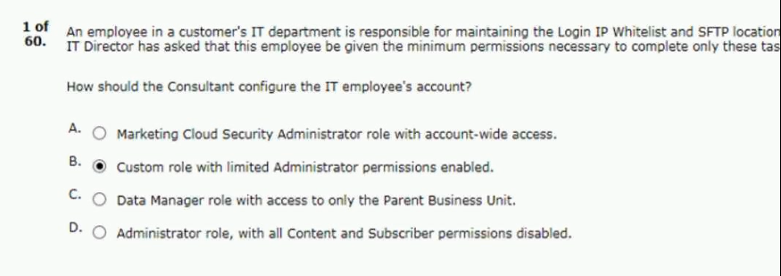
- a customer team wants to retarget subscribers
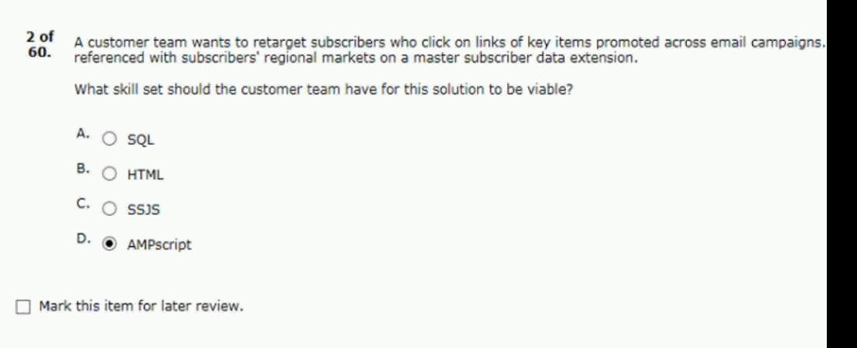

- a retail company’s database of record resides at a third-party company
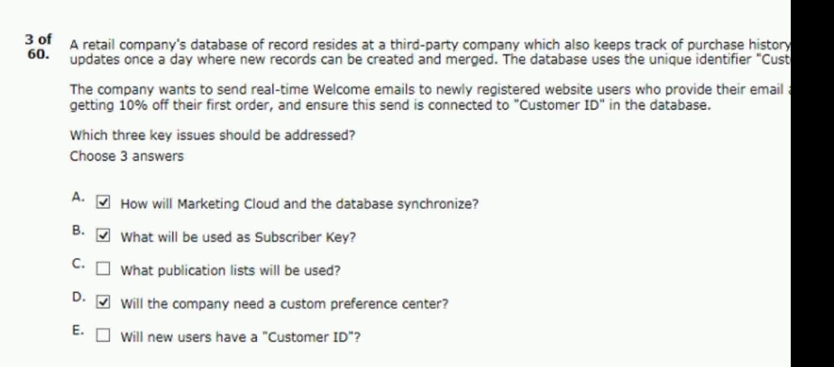
- a customer will provide a single daily file on the marketing cloud
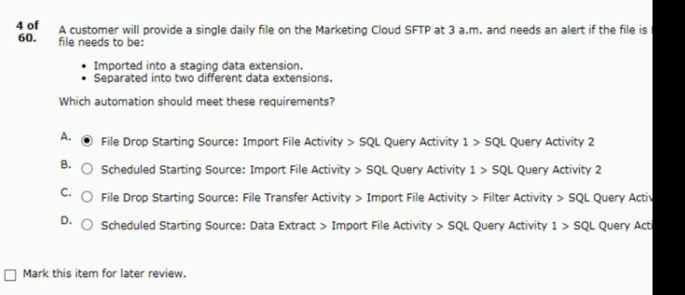

- a customer has an email newsletter to send out
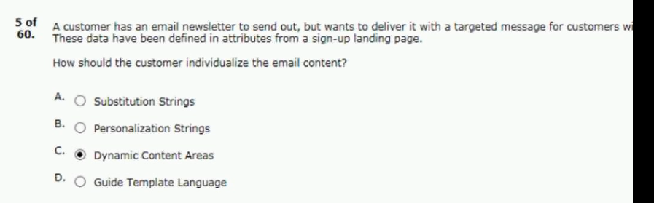
- a customer wants to send an email from sales
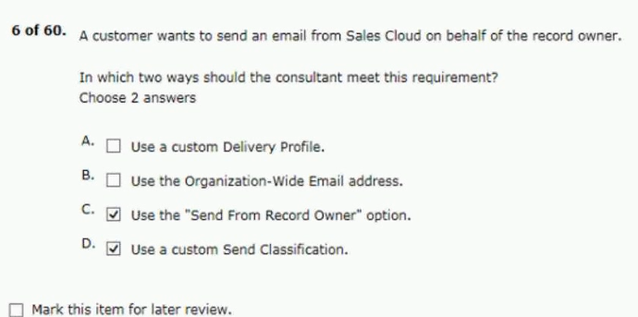

- which two statements are accurate regarding
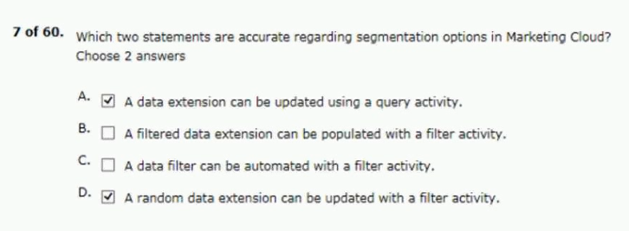
- in which two ways can contact builder
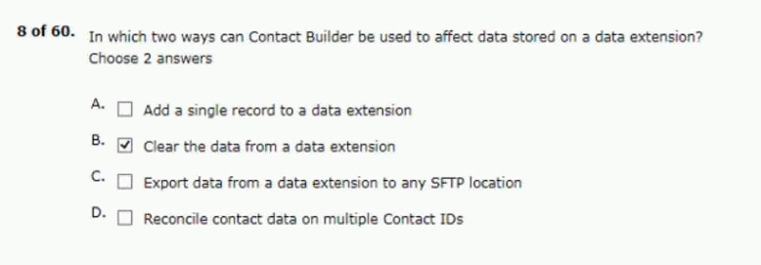
- northern trail outfitters (NTO) is launching a new campaign
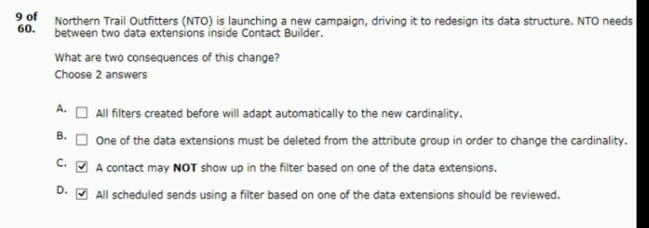

- what are two possible outcomes when
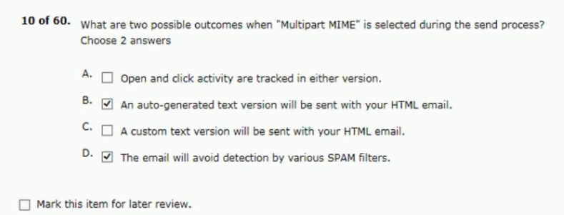
- a customer needs to link demographic information
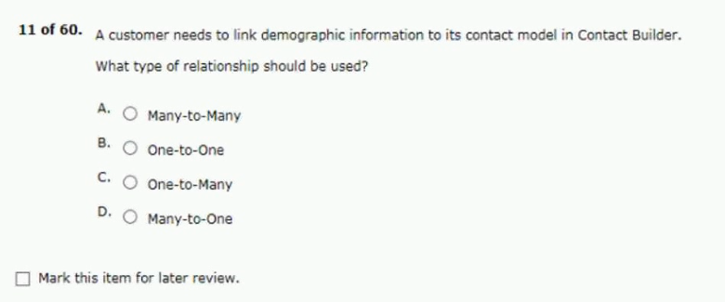
Answer - C

- which two statements are correct regarding
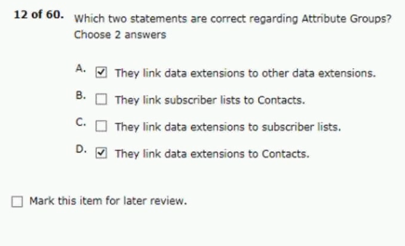
- northern trail outfitters (NTO) has a requiremenr
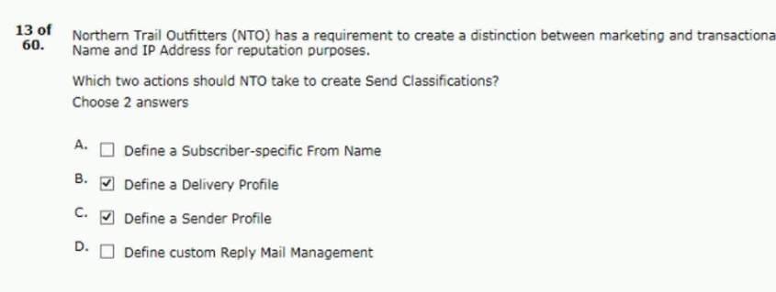

- a company is hosting a series of events
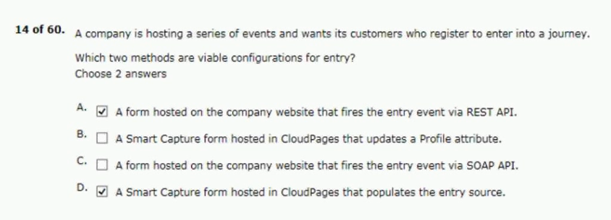
- a university plans to use journey builder
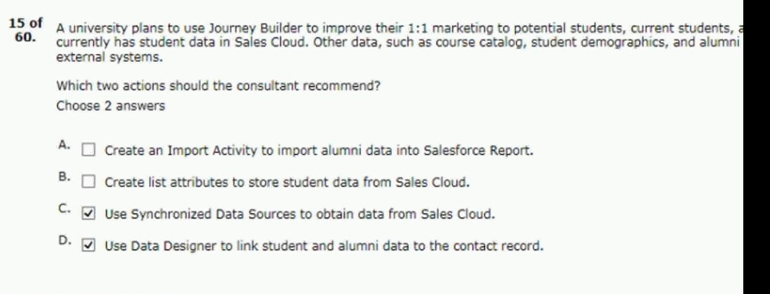
- a start-up meal delivery company recently
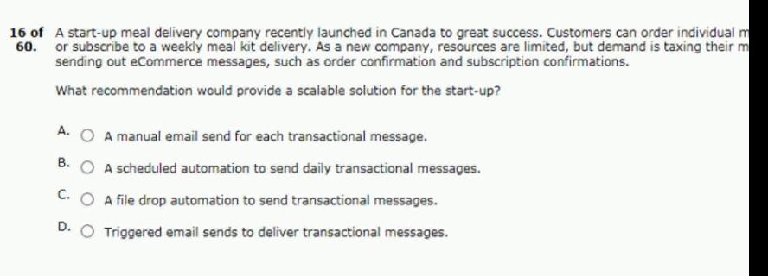
Answer - D
- subscribers are collected on a customer’s
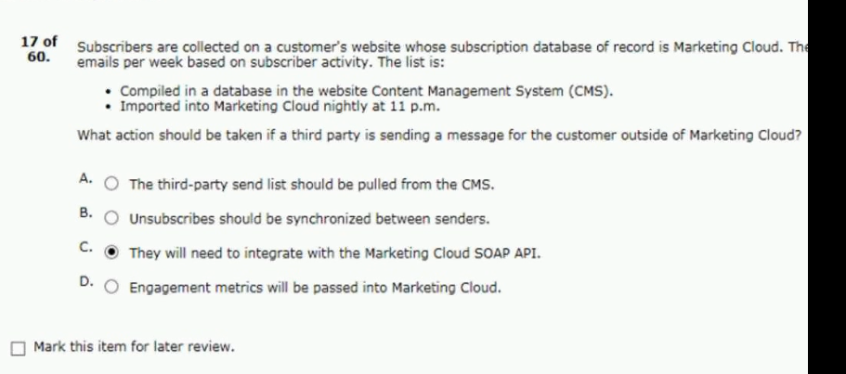
- what functionality is contained in journey
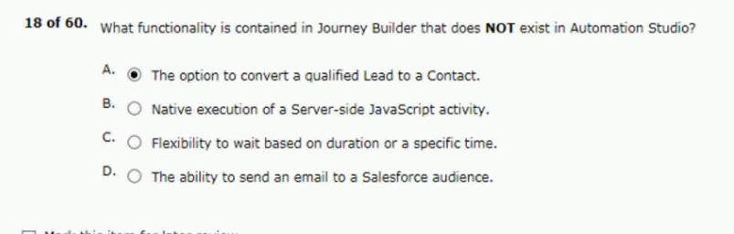
- the corporate apparel division of northern
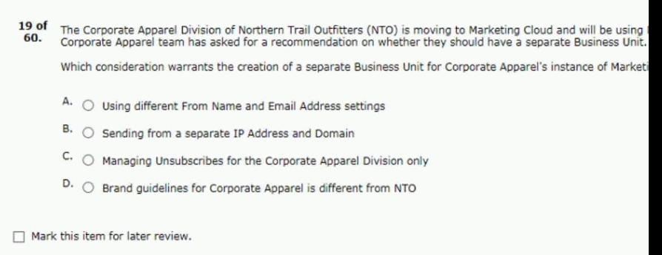
- a consultant has a data extension that contains
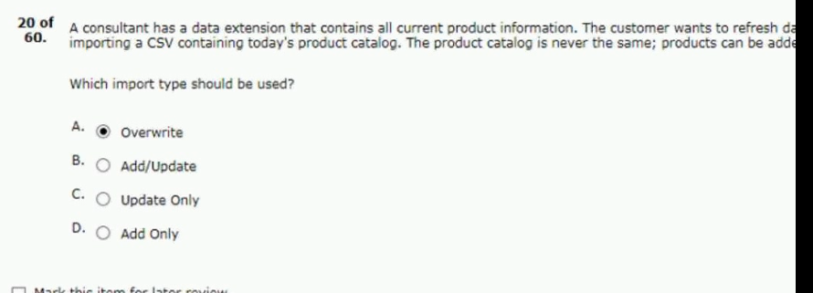
- a consultant wants to send an email
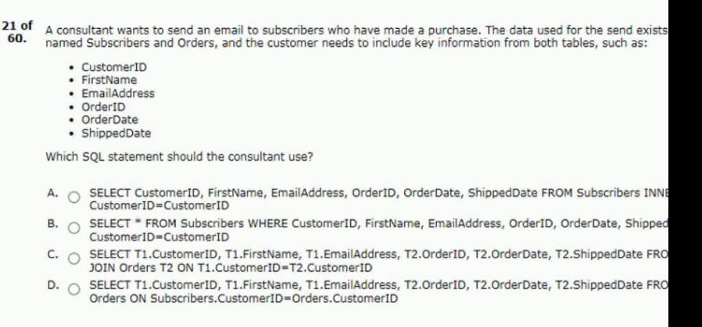
Answer - C

- northern trail outfitters assigns a 15-digit
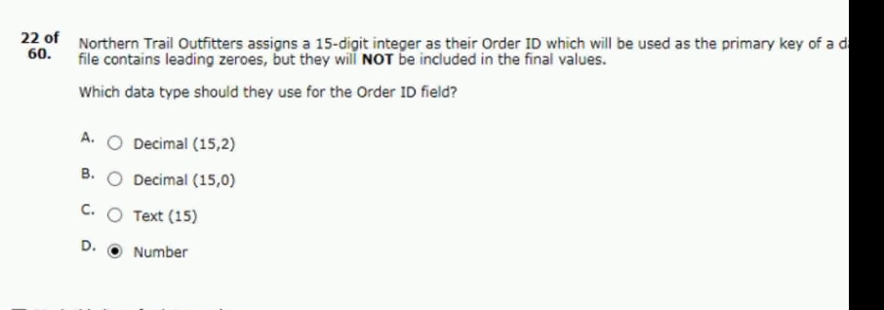
- an entertainment company is hosting
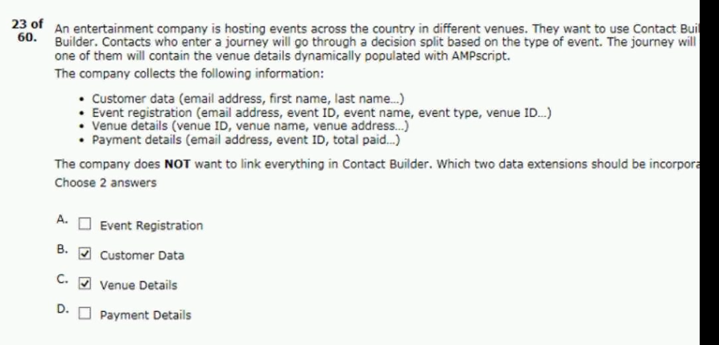

- a retail company does business in both the united states
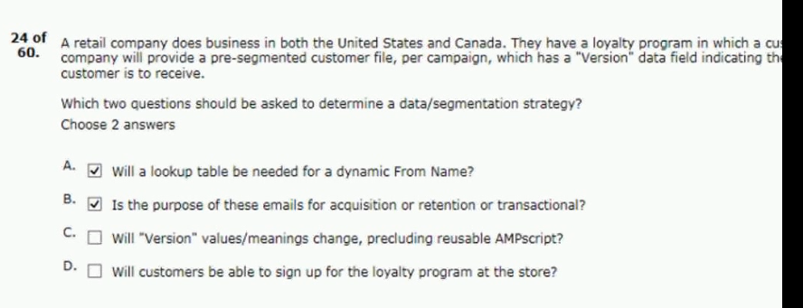
25.a customer wants sales cloud users
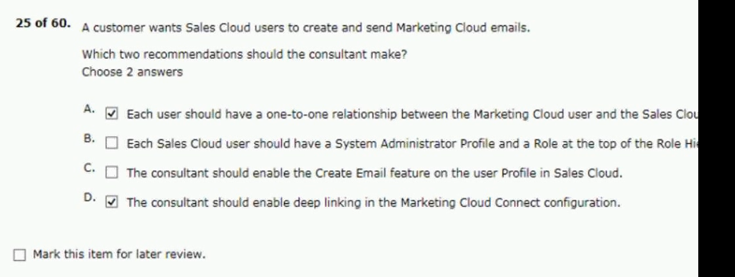

26. a subscriber asked to be removed from a customer’s email
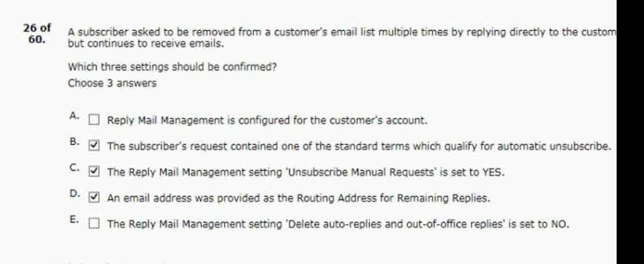
27. during discovery, the customer outlines data
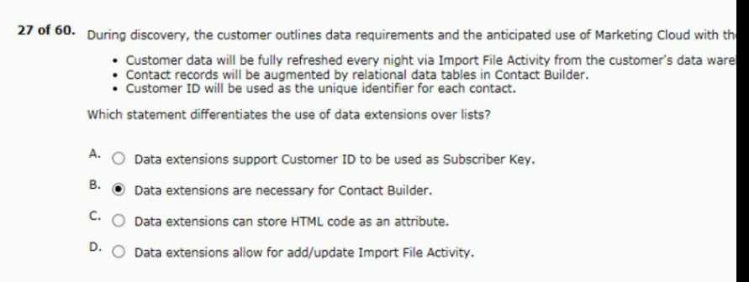

28. a pharmaceutical company is hosting a monthly event
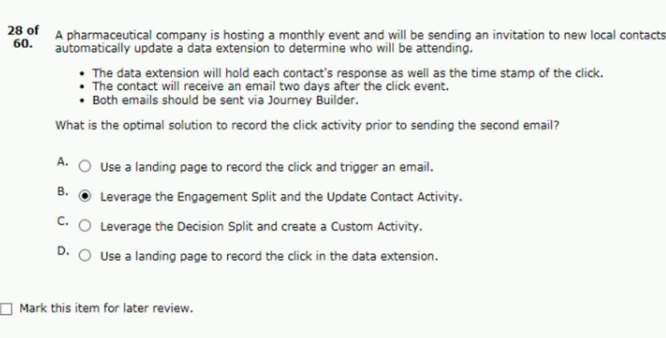
29. a user is marketing cloud needs to send an email
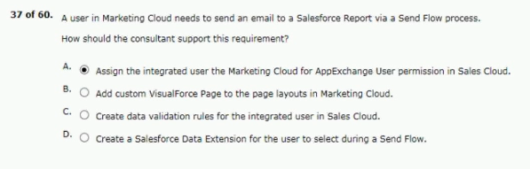

30. what storgar model should be used if a subscriber
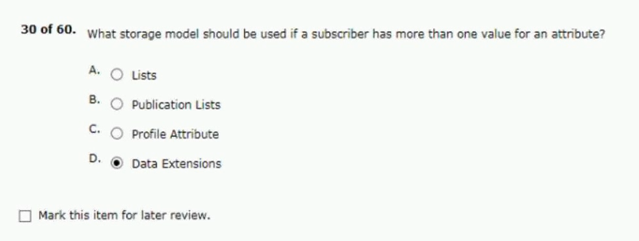
31. northern trail outfitters (NTO) wants to use dynamic
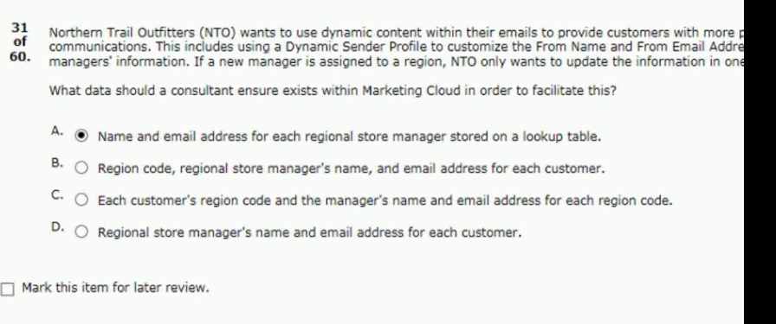

32. northern trail outfitters wants to reduce the amount of work
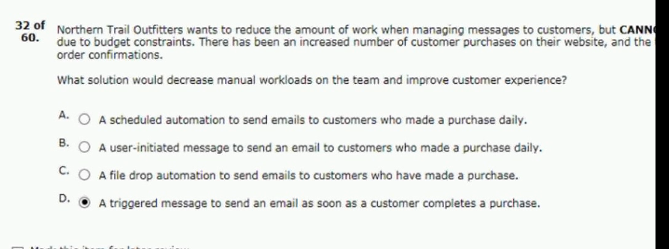
33. the northern trail outfitters (NTO) marketing team
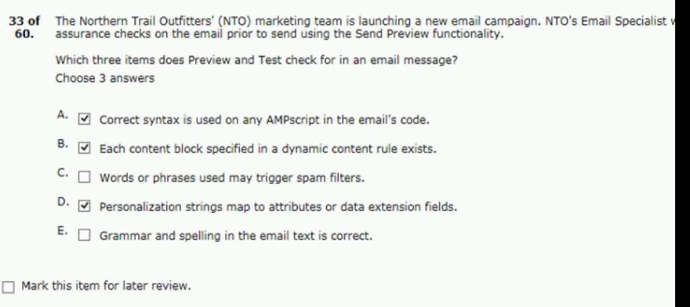

34. a customer with limited technical resources
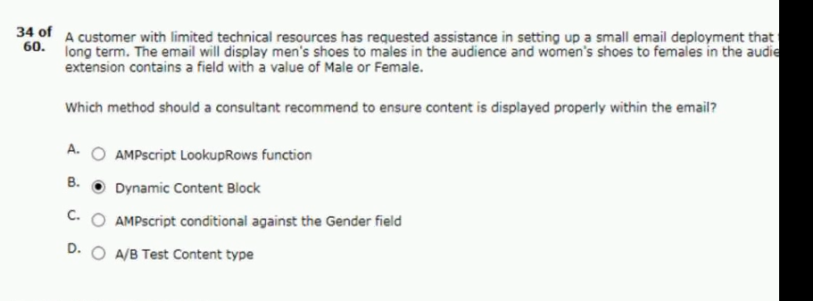
35. which two statements about a database
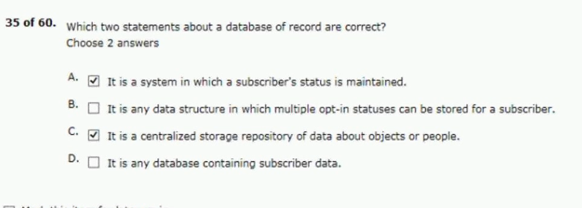

36. a publishing company has presented
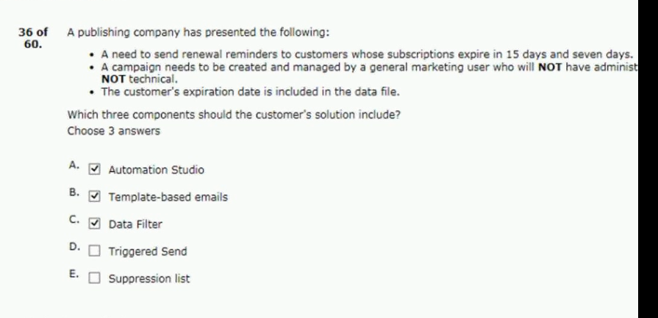
37. a customer needs to compare the engagement
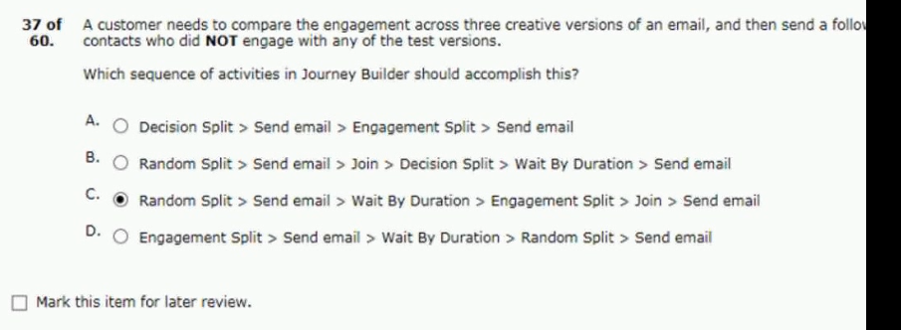

38. northern trail outfitters (NTO) has decided
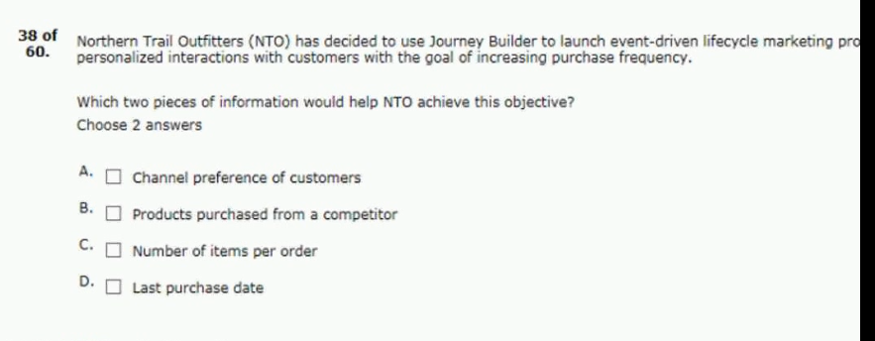
39. an existing triggered send needs to be
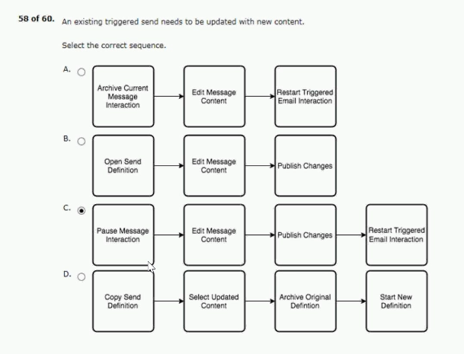

40. a customer wants to automate the send
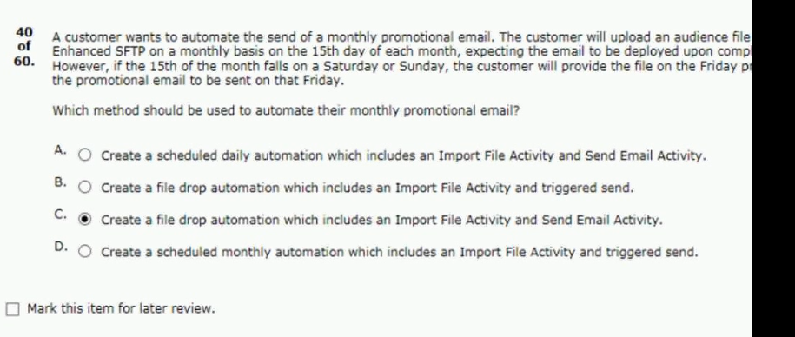
41. an entertainment customer has added
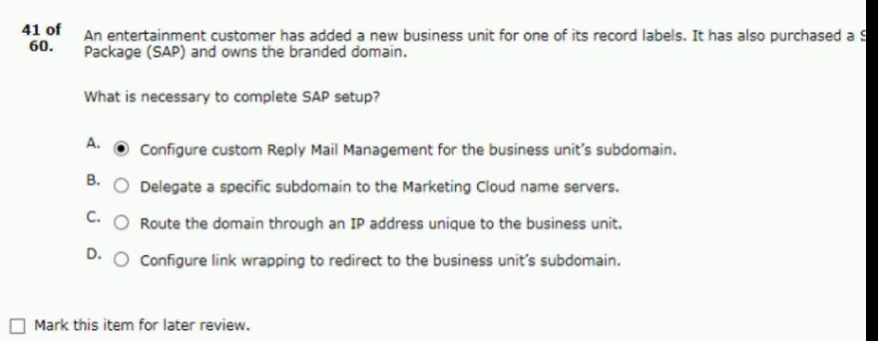

42. what are two capabilities of the import
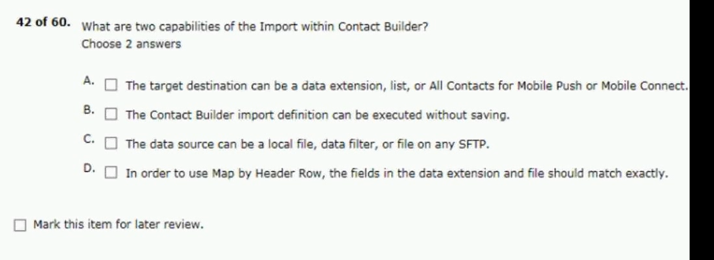
43. a customer wants to automate a series
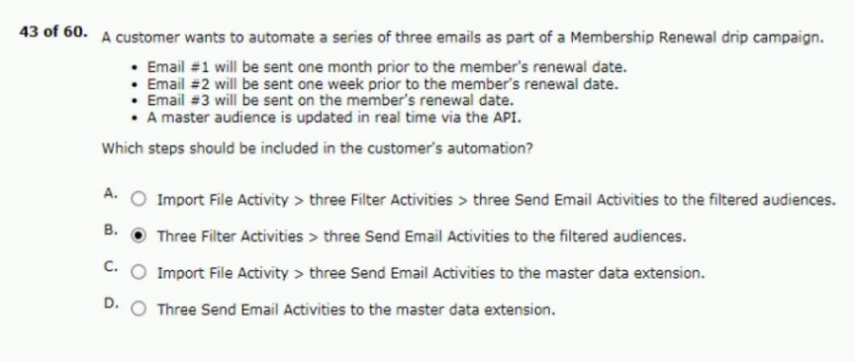

44. a large retail group consists of a corporate
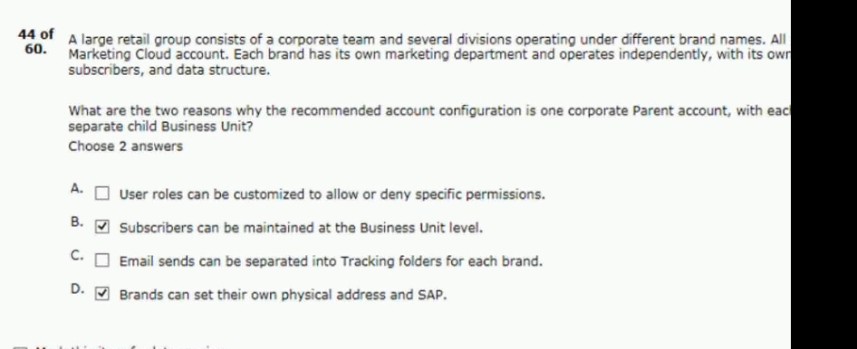
45. a financial company wants to use
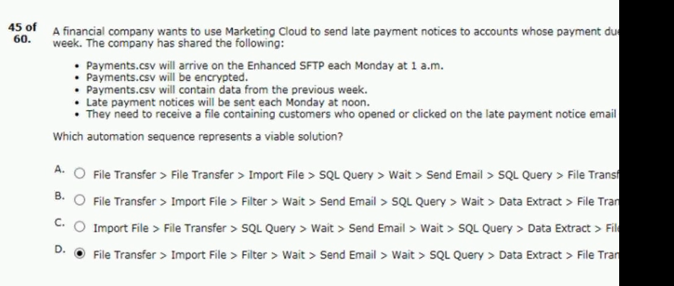

46. a customer has an ecommerce site and imports
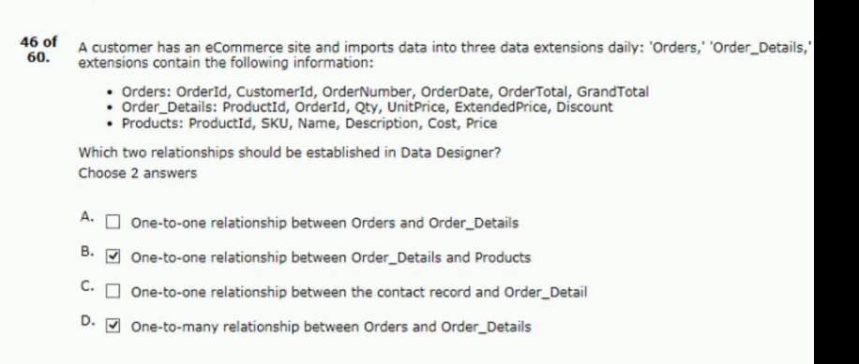
47. northern trail outfitters (NTO) wants to implement
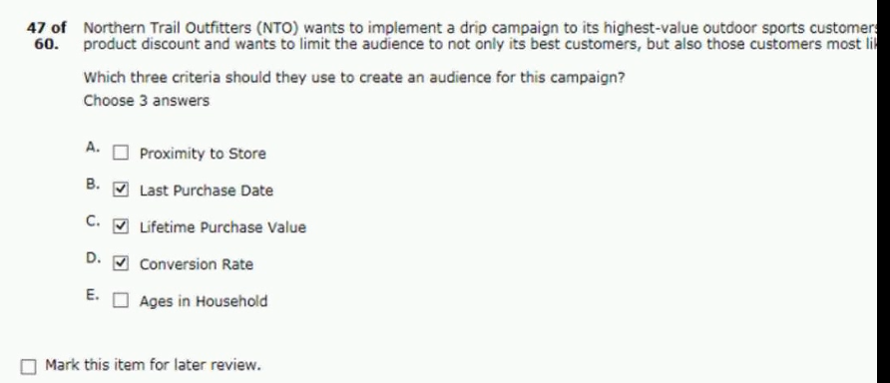

48. by which three standard methods could contacts
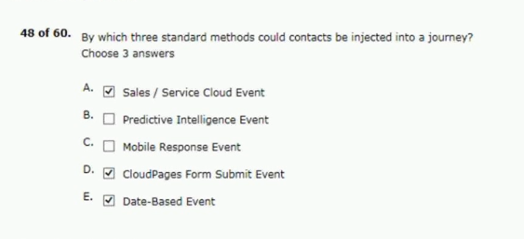
49. northern trail outfitters wants to set up
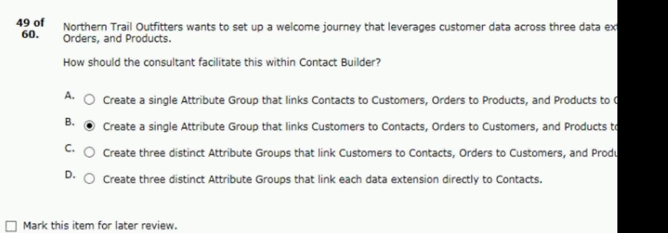

50. a customer wants to segment point of sale
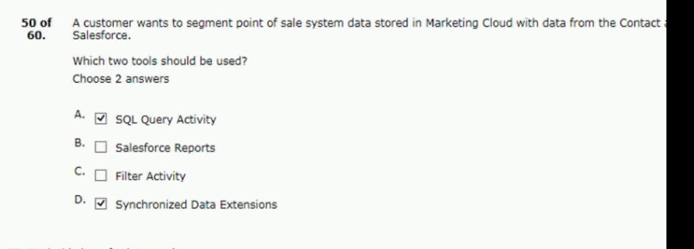
51. a marketing cloud user needs the email addresses
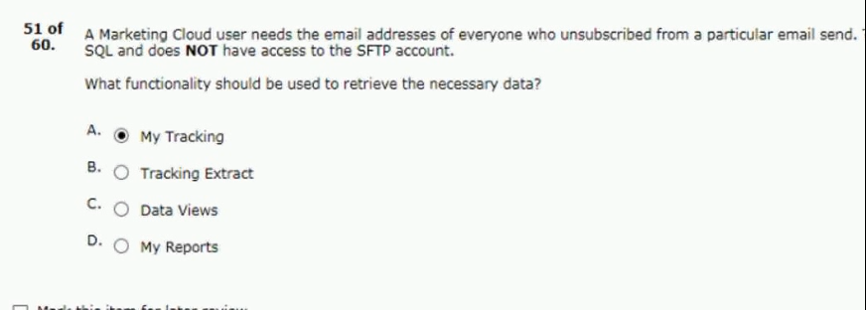

52. northern trail outfitters (NTO) wants to better understand subscriber
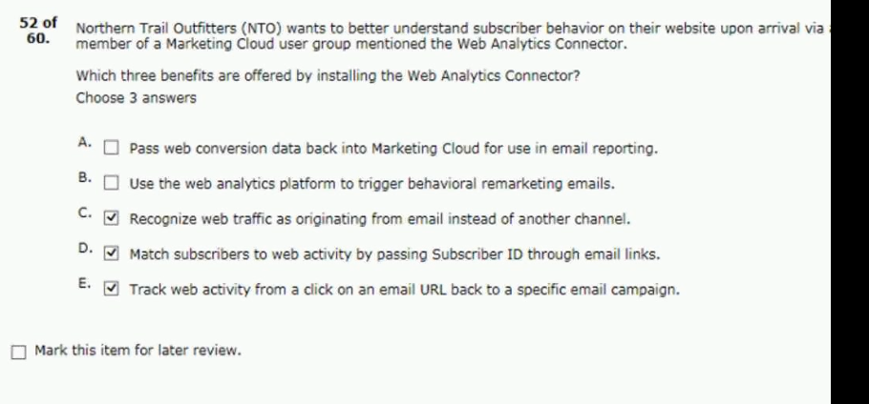
53. a restaurant supply company captures email subscribers
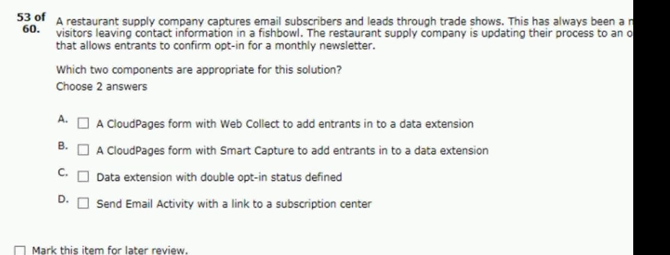
Answer - AB
54. during discovery a consultant confirmed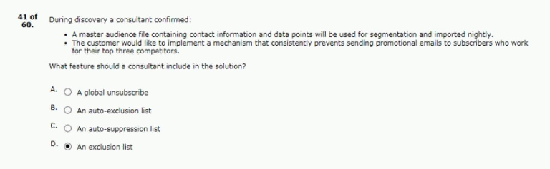
55.data will need to be kept in sales cloud.
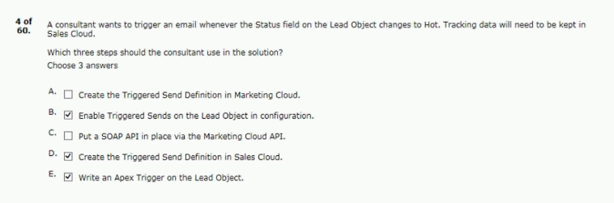
56.about send log data are correct?
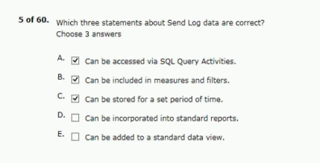

57.as its current customer master database.
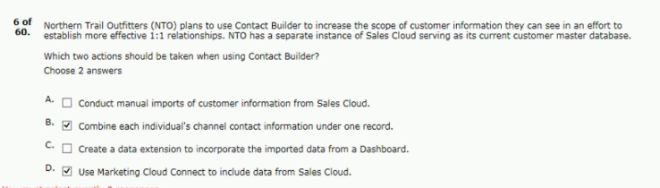
58.web analytics data to subscribe data.
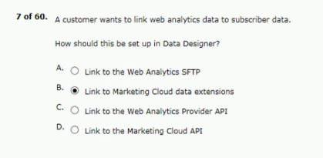
59.welcome emails based on the subscriber’s data.
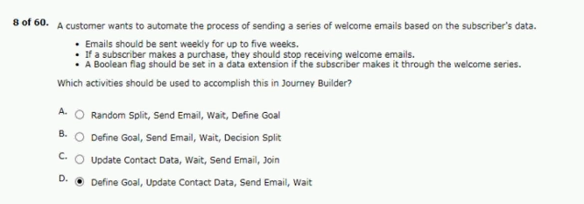

60.who report their email as spam.
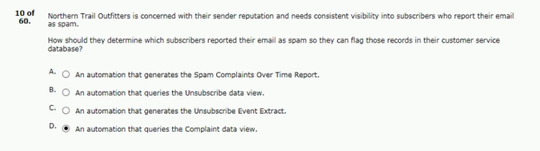
61.effects of five international offices.
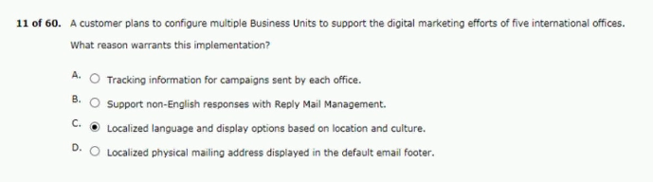
62.campaign for each of NTO’s business units:
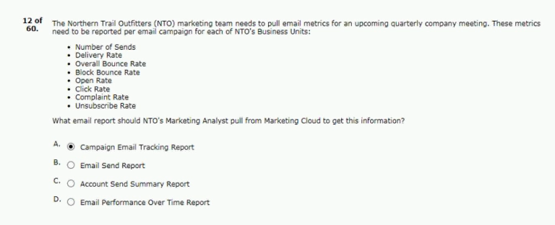

63.automations tools in marketing cloud?
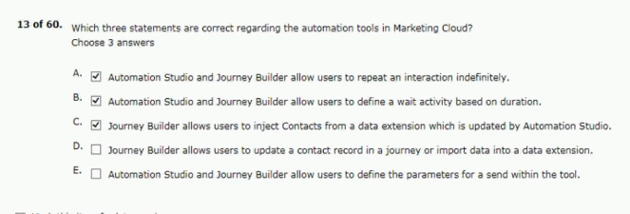
64.as journey builder in the future.
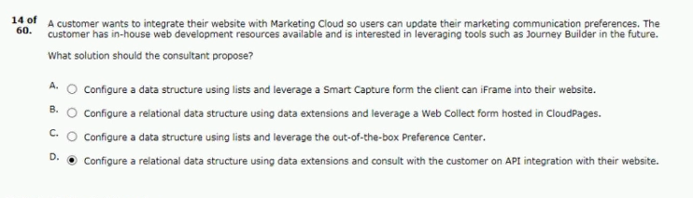
65.return tracking to sales cloud.
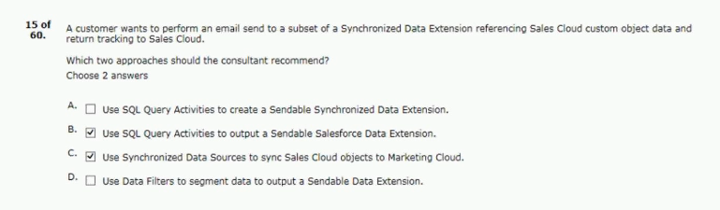

66.abandoned a cart and made a purchase.
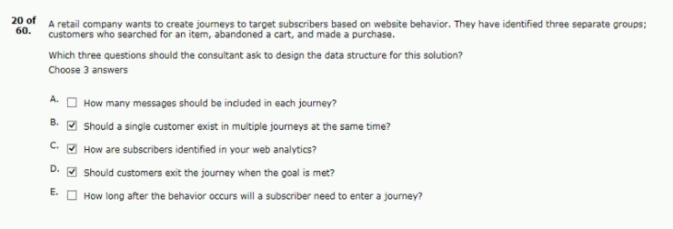
67.related to invoicing in its data extensions.
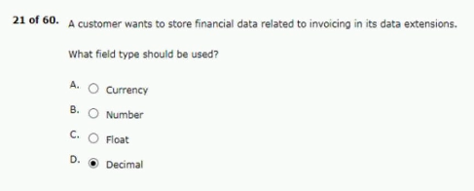
68.accounts within 72 hours of registration.
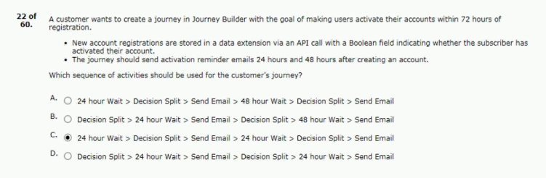

69.are correct about data designer?
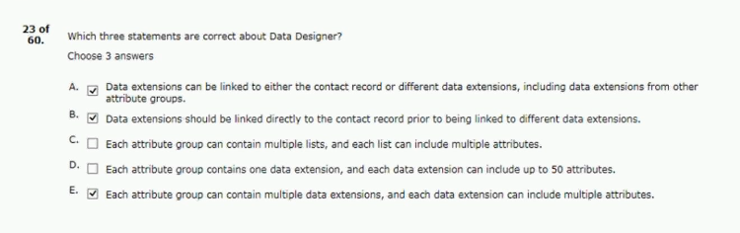
70.includes 1.5 million email addresses.
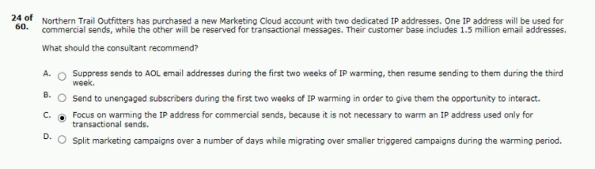
71.affect data stored on a data extension?
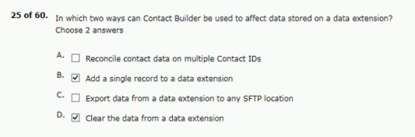

72.type of email the customer is to receive.
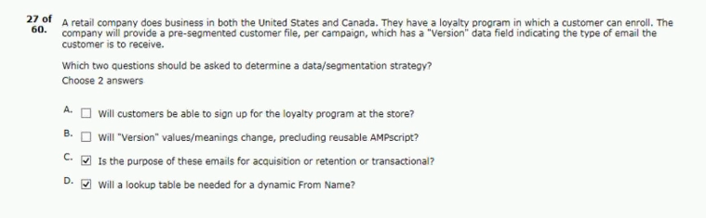
73.is stored in external systems.
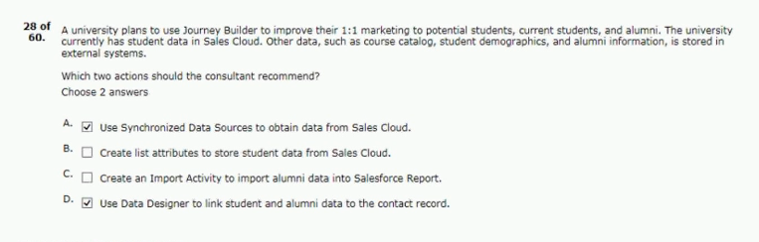
74.key information from both tables such as:
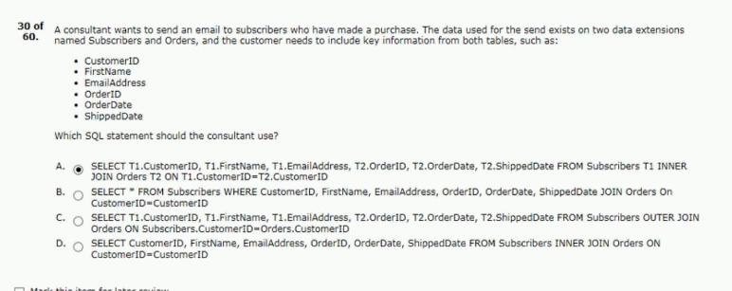

75.northern trail outfitters (NTO)
its absolutely necessary.
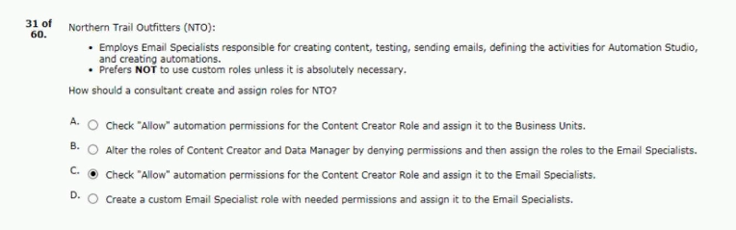
76.designer and linking its data extensions.
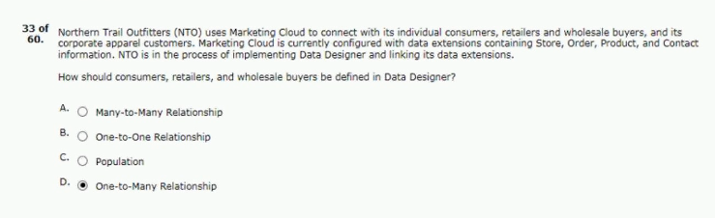
77.used in the body of an email send:
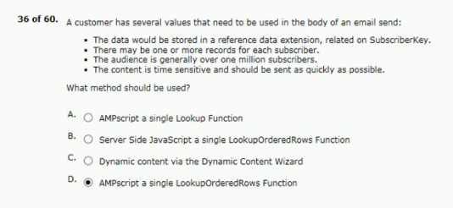

78.on its website it does the following:
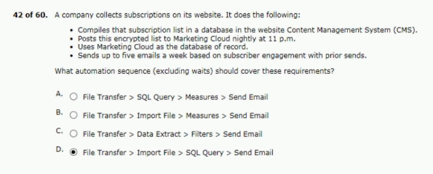
79.current account and other bank offerings.
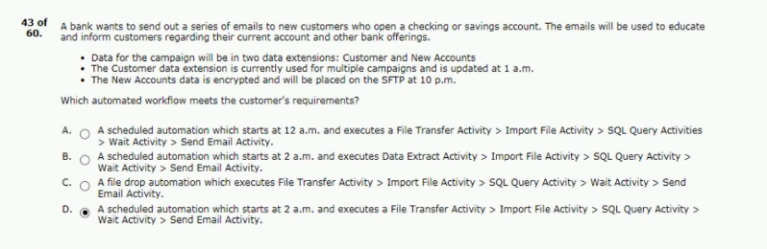
80.com as an additional private domain.
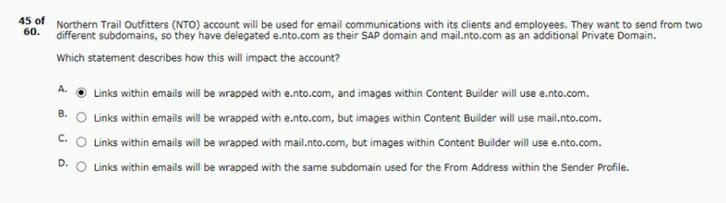

81.the customer’s plans are to:
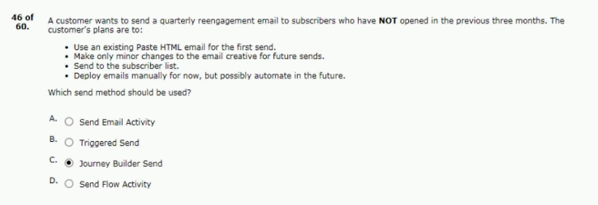
82.from an sftp site the customer wants to:
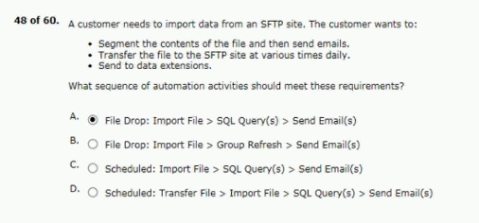
83.center will be used as part of the solution.
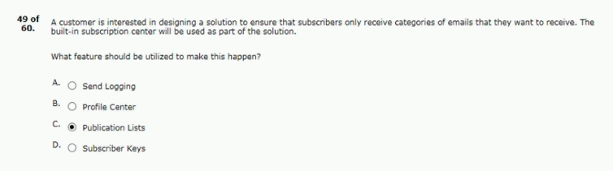

84.correct regarding attribute groups?
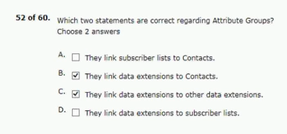
85.generates reports and manage subscriber data.
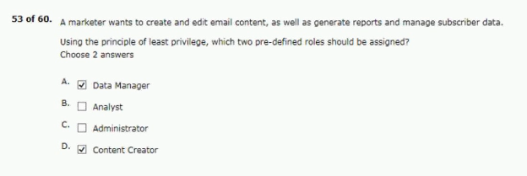
86.records exported from its marketing database.
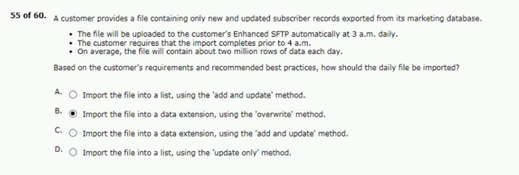

87.to create an opt-down strategy of customers?
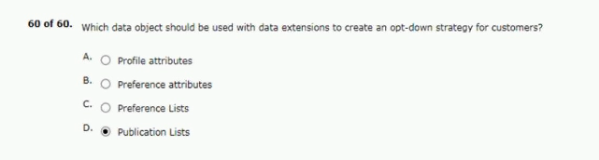
88.storing engagement data in their data warehouse:
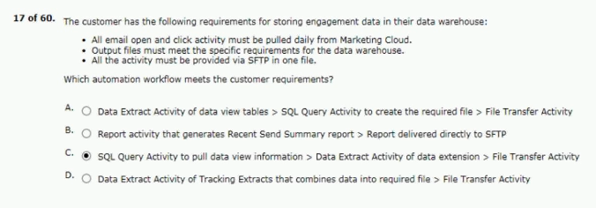
89.dynamic template for this purpose.
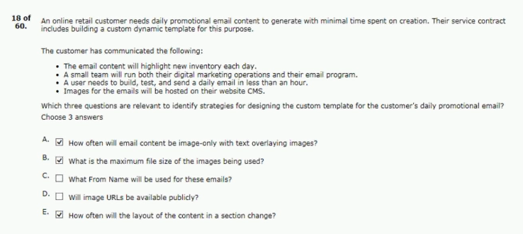

90.are correct regarding tracking aliases?
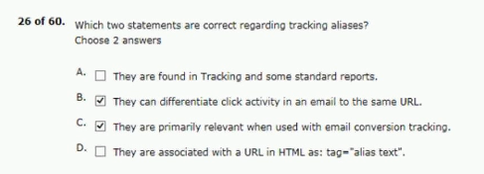
91.the site and continue their shopping.
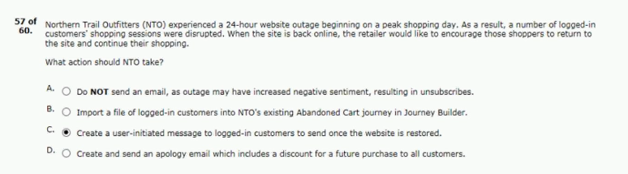92. content testing within journey builder?
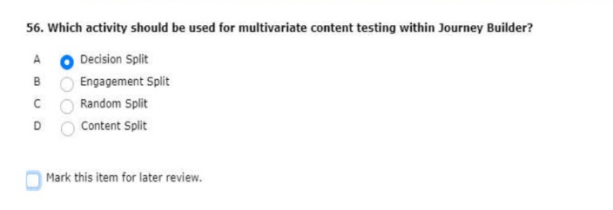
Ans - Dout

93. 10 miles of one of their stores
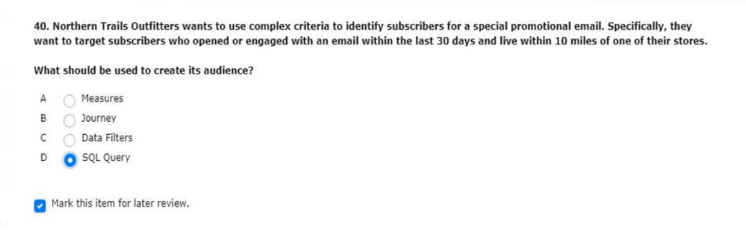
Ans - Dout

94. email sent via email studio
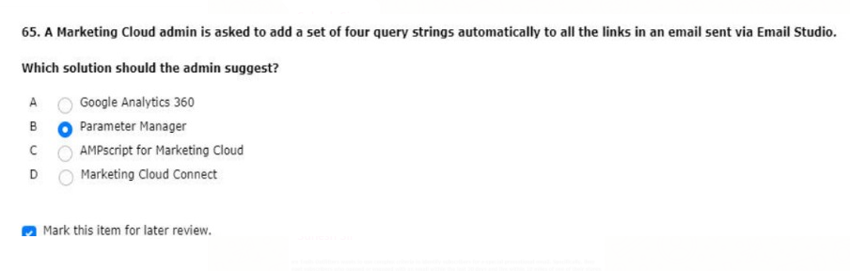
Ans - Dout
sent to customers when the file transfer has completed.
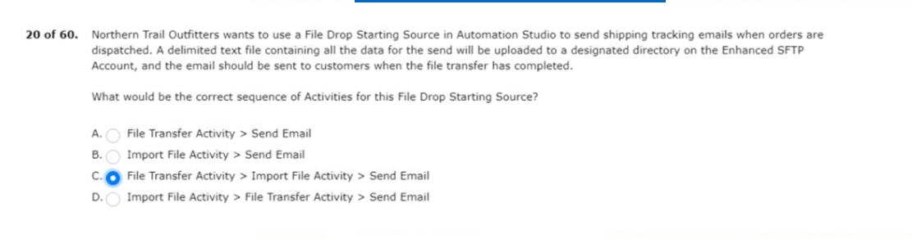
frequent intervals to a folder on their enhanced SFTP account.
